**SECTION A: 40 MARKS**

*Answer all questions in this section.*

*Questions* ***1*** *to* ***20*** *carry two marks each.*

1. Work out: $-\begin{matrix}7 & 5 & 9 \\ 4 & 3 & 4\end{matrix}$
2. Write “Forty-four thousand, forty-eight” in figures.
3. Given that a = 2 and b = -3, find the value of 2a**2** – b
4. Simplify $\frac{4}{12}÷\frac{3}{18}$
5. Find the value of **r** in the diagram below.

3r

72**0**

57**0**

1. Given that set **P = (a, b, c, d)** and set **Q = (a, r, b, d, n).** Find **n(Q – P)**
2. Find the number of packets of tea each 450 grammes that can be obtained from 6 boxes each weighing 22.5kg.
3. Musa had Ug shs.210,000 he exchanged from a forex bureau at the rate 1K sh. = Ug shs.30. How much Kenya shillings did he get?
4. Find the value of **d**. 3 – 5 = **d** (finite 7)
5. Find the sum of the first 4 natural even numbers.
6. Express 17:45 hours as a 12-hour clock.
7. Using a pair of compasses, ruler and a pencil only bisect the reflex angle in the diagram below.

1. Find the value of 2 in 3241***five.***
2. Work out the lowest common multiple (L.C.M) of 12 and 15.
3. Two thirds of the class was present on Friday last week, $\frac{1}{4}$ of it was girls. Find the fraction of boys present.

1. The weight of a supervisor in a company in 75kg. When one worker joins the three workers, the average weight of the supervisor and workers becomes 50kg. Find the weight of the workers.
2. A cyclist rides a bicycle at an average speed of 16km/h, for one hour and thirty minutes. Calculate the distance the cyclist covered.
3. Simplify (4q – 6) – (3q – 8)

1. Kato was given sh.1500 for lunch. Two people were demanding him some money he paid the first one shs.500 and the second one shs.200 more than the first one, find the amount of money Kato remained with.
2. Find the number of strides of 30cm a builder can make to cover a distance of a building 45 metres high.

**SECTION B: 60 MARKS.**

***Answer all questions in this section.***

***Marks for each question are indicated in brackets.***

1. 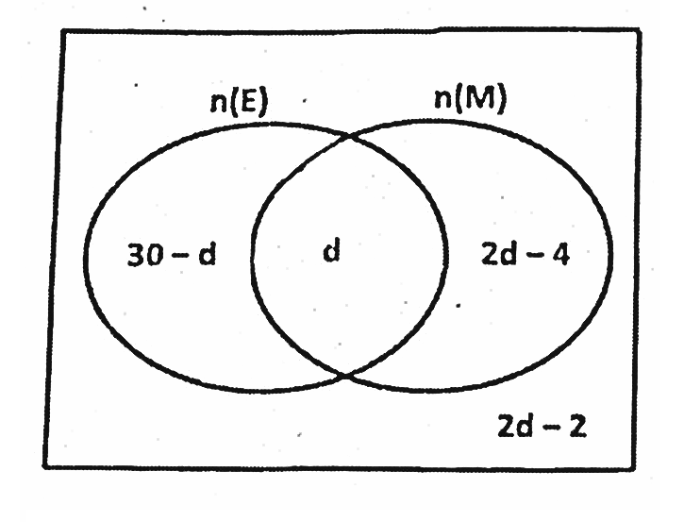In a class, **2d – 4** pupils like Mathematics (M) only, **d** pupils like both Mathematics and English (E), **30 – d** pupils like English (E) only while **2d -2** pupils like neither Mathematics nor English. Study the Venn diagram below and answer the questions that follow.
2. Find the value of d, if **n**($E∪M$) =36

**(02marks)**

1. Work out the number of pupils who do not like English at all.

**(02marks)**

1. Find the total number of pupils in the class.

**(02marks)**

1. A mother is three as old as her son who is P years old. In two years’ time, the product of their ages will be 8(p+38)

a) Find the mother’s actual age now.

**(03 marks)**

1. Work out their total age now. ***(02marks)***
2. a) Find the principle that will amount sh.138,000 at a rate of 5% per year for 3 years.

**(03marks)**

1. Find the simple interest after 3years. **(02marks)**
2. In the diagram below, a square is enclosed in a circle. Use it to answer the questions that follow.

n

If the area of the shaded part is 56cm**2**. Find the value of n.

**(05marks)**

1. The range of two numbers is 8 and their sum is 32. Find the numbers.

**(04marks)**

1. a) Complete the shopping table bill. **(04marks)**

|  |  |  |  |
| --- | --- | --- | --- |
| **Item** | **Quantity** | **Unit cost** | **Amount** |
| Beans | 2kg | Sh.4,000 per kg | Sh..................... |
| Peas | ..........kg | Sh.5,000 per kg | Sh.1,400 |
| Soya beans | 2½kg | Sh..................per kg | Sh.7,500 |
| **Total expenditure** | | | Sh..................... |

b) If Martha paid Sh.16,300, find the discount she received. **(02marks)**

1. A worker spent $\frac{2}{7}$ of her salary on Monday, $\frac{2}{5}$ of the remainder on Wednesday and the rest on Friday. If he spent sh.18,000 on Friday, find the worker’s salary.

**(05marks)**

1. Below is a timetable for the taxi travels from Gulu to Kampala.

|  |  |  |
| --- | --- | --- |
| **Town** | **Arrival time** | **Departure time** |
| **Gulu** |  | 8:45am |
| **Karuma** | 9:25am | 9:35am |
| **Luwero** | 10:20am | 10:40am |
| **Kampala** | 12:15pm |  |

1. Write the time the taxi arrived Kampala in 24-hour clock.

**(02marks)**

1. If the taxi travels at an average speed of 60km/h. Find the distance from Kampala to Gulu.

**(03marks)**

1. In the diagram below, **BF** is parallel to **CD**. Study the diagram and answer the questions that follow.

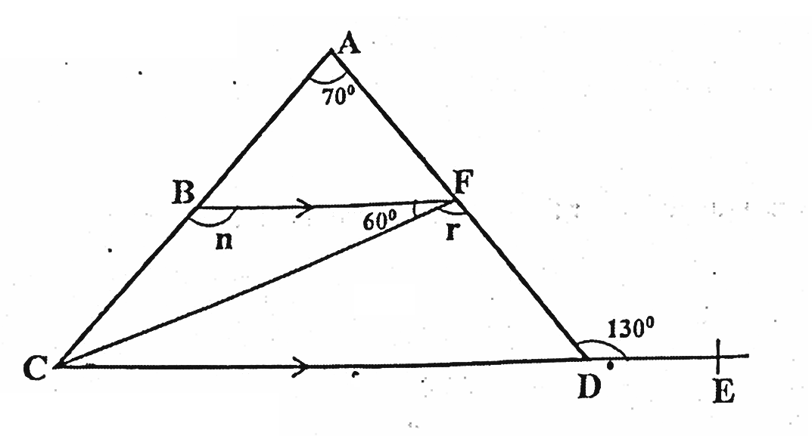

F

Find the size of;-

1. angle **r**.
2. angle **n**.
3. The table below shows the marks scored by pupils in a P.7 class for mock exams.

|  |  |  |  |  |
| --- | --- | --- | --- | --- |
| **Marks** | **40** | **r** | **60** | **70** |
| **No. of pls** |  |  |  |  |

1. If the mean mark was 55, find the value of **r**. **(04marks)**
2. The figure below is a rectangular metal which is to be folded into a hallow cylinder.

**100cm** height

**88cm**

1. Find the volume of the cylinder. **(04marks)**
2. Work out the capacity of the cylinder. **(01mark)**
3. A fisherman left town **P** and travelled 50km west wards to town **Q**. He then turned on a bearing of 220**0** and travelled to town **R** which is a distance of 65km.
4. Using a scale of **1cm** to represent **10km**, draw an accurate diagram for the fisherman **(04marks)**
5. Find the shortest distance between towns **P** and **R** in km.

**(02marks)**

END